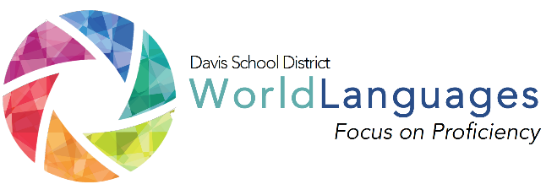
LEVEL: TWO
UNIT: ONE
DAY: THIRTEEN

DESK Standard: I can present information about a familiar person, place, or thing using phrases and simple sentences.
Unit Can-Do statement: I can have a conversation about a popular restaurant I visited and what I ate there. I can talk about the different types of food and restaurants in my community.
 | What will students  be able to do? |  | What will students  need to know? |  | How will students demonstrate what they can do with what they know?
 | “Daily” Learning Targets |  | Language Chunks | Other Vocabulary | Check for Understanding or Mini Performance Assessment
 | I can compare popular restaurants from my community and the target language country.  I can compare the types of foods in my community to the target language country. |  | You can ask for…  How was it?  It was… | to really like  there is / there are  to prefer  yummy | Students will create food images of themselves as well as email the teacher.
 | INPUT:  Interpretive reading/listening  “I Do” | Describe the input activity the teacher will do to input the language chunks, vocabulary, and model what students will be able to do by the end of the lesson.
 |  | The teacher will list 4 foods they like from American culture and 4 foods they like from the target language country. The teacher will then use Playdoh to create an image of themselves using the 8 foods they listed. After modeling what they are doing, the teacher may assess for understanding.
 | PROCESSING:  Interpretive reading/listening  “We do” | Describe the processing activity students will do together, with gradual release of responsibility on the part of the teacher.
The students will write a list of 4 American foods that they like as well as 4 foods from the target language country that they might like. After the student is done with their list, they should show it to the teacher, who reviews it and then provides Playdoh to the student.

The student must use the Playdoh to create an image of themselves using the 8 foods they wrote down.
 | OUTPUT:  Interpersonal or Presentational  “you do” | Describe what students will do on their own to demonstrate their ability to accomplish the daily learning targets.
The students will need to speak with classmates to ask them what their person is made of. The student explains the different foods that make up their person and then the classmate has the choice to “steal” one of their body parts by saying “I need…” The classmate then “trades” the body part of their Playdoh creation with the one stolen from the student and gives them their original part. The object of this activity is for students to try to form the “healthiest” person using foods taken from other classmates. One rule to consider; body parts may only be taken once, after it has been stolen once, it cannot be taken again by anyone.

After the allotted time, discuss with the class foods from both cultures and their varying healthiness. The student with the “healthiest Playdoh body” wins.
FORMATIVE PERFORMANCE ASSESSMENT: Students will use smart phones (as available) to email the teacher comments, questions, and suggestions about the lesson.

