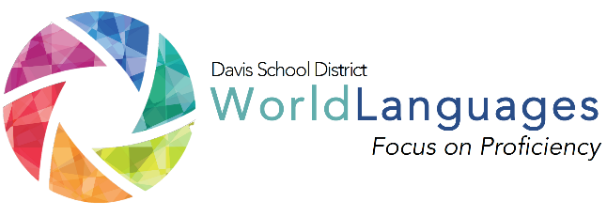
LEVEL: THREE
UNIT: ONE
DAY: THREE

DESK Standard: I can understand some information from media.
Unit Can-Do statement: I can understand and follow a recipe I see on YouTube.
 | What will students  be able to do? |  | What will students  need to know? |  | How will students demonstrate what they can do with what they know?
 | “Daily” Learning Targets |  | Language Chunks | Other Vocabulary | Check for Understanding or Mini Performance Assessment
 | I can understand and follow recipe instructions. |  | informal commands | units of measurement  pertinent ingredients  to cut  to mix  to add | Students will submit a short food tutorial video for teacher assessment.
 | INPUT:  Interpretive reading/listening  “I Do” | Describe the input activity the teacher will do to input the language chunks, vocabulary, and model what students will be able to do by the end of the lesson.
Teacher will display two pictures. One of a meal at a restaurant, the second of someone preparing a meal at home. Students will briefly discuss in small groups which of the two is the healthier choice and why.

Teacher will model and then unpack necessary vocabulary (ingredients, to contain, etc.)
 | PROCESSING:  Interpretive reading/listening  “We do” | Describe the processing activity students will do together, with gradual release of responsibility on the part of the teacher.
Show 2 or 3 30 second YouTube cooking video clips. The videos should be muted unless the teacher can locate one in the target language. The clips should contain recipes being created for American foods only.

Students will determine 1) what food is being made 2) explain why they decided that was the food being prepared 3) discuss if the food is healthy with supporting details.
 | OUTPUT:  Interpersonal or Presentational  “you do” | Describe what students will do on their own to demonstrate their ability to accomplish the daily learning targets.
 |  | In groups, students will make a short “youtube” food tutorial video in their target language using a smartphone (or if you have access to ipads, or be creative with what’s available at your location). Teacher will provide props or give time for students to create their own props to use.
FORMATIVE PERFORMANCE ASSESSMENT: Quick thumbs up or down. Ask the students if they understand what they watched. The students will give a thumbs up for yes, down for no, or sideways for “more or less.”

