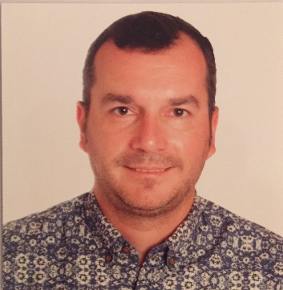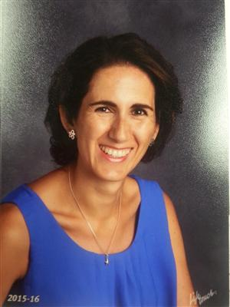

**Fermin Soriano**

Spanish teacher, Farmington Jr. High

Bridge teacher,

Viewmont High

**Ingrid Campos**

Spanish teacher, Bridge Teacher

Layton High

**Project-Based Language Learning Seminar**

**Project Based Learning**is a teaching method in which students gain proficiency, knowledge, and skills by working for an extended period of time to investigate and respond to an authentic, engaging and complex question, problem, or challenge.

Join Fermin and Ingrid, who have recently completed a year-long intensive study of PBLL, for this unique and timely seminar.

|  |  |
| --- | --- |
| **Dates** | **Topic** |
| Sept. 14 | Introduction to PBLL |
| Sept. 28 | Project integrity / driving questions / project square |
| Oct. 5 | Student involvement / authenticity / sustain inquiry (blueprint) |
| Oct. 12 | Career pathways / project management |
| Nov. 2 | Scaffolding |
| Nov. 16 | Interviews |
| Nov. 30 | Project Presentation / peer feedback |
| May – TBD | Implementation Feedback |

Participants will:

• Develop an instructional unit incorporating the essential design elements of PBLL, the Utah World Language Standards, and 21st Century Skills, with a focus on target language proficiency development in all three modes of communication, oral and written;

• Understand how to scaffold and manage a project-based unit from start to finish;

• Learn how to incorporate technology tools to engage students in their own learning, to scaffold project development and implementation, and to offer students voice and choice.

Target Audience: All teachers of World Languages (including American Sign Language).

Participants should bring a laptop if possible.

Participants are expected to complete 16 hours of face-to-face time as well as 9 hours of homework.

All sessions begin at 4:15 PM and end at 6:15 PM.

*To register, email Margo Hammond at* [*mhammond@dsdmail.net*](mailto:mhammond@dsdmail.net)*.*

*Class size is limited to 12 participants.*