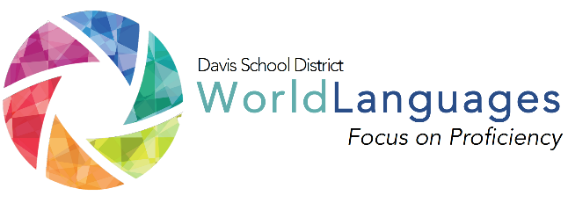
LEVEL: THREE
UNIT: TWO
DAY: TWELVE

DESK Standard: I can have a conversation about familiar, everyday topics.
Unit Can-Do statement: I can describe my entertainment preferences. I can present information on one of my favorite past-times or hobbies.
 | What will students  be able to do? |  | What will students  need to know? |  | How will students demonstrate what they can do with what they know?
 | “Daily” Learning Targets |  | Language Chunks | Other Vocabulary | Check for Understanding or Mini Performance Assessment
 | I can compare my entertainment preferences and daily activities with those of a target language country. |  | It fascinates me.  It makes me feel like…  It seems to me… | student driven entertainment vocabulary | Students will present a Twitter board that summarizes what they learned and submit it to the teacher.
 | INPUT:  Interpretive reading/listening  “I Do” | Describe the input activity the teacher will do to input the language chunks, vocabulary, and model what students will be able to do by the end of the lesson.
The teacher will show various forms of social media and discuss if they use any, if they have a favorite, etc. The teacher should also discuss which social medias are available and popular in the target language country.

The teacher should also discuss what kind of things they like to make known on the different kinds of social media.
 | PROCESSING:  Interpretive reading/listening  “We do” | Describe the processing activity students will do together, with gradual release of responsibility on the part of the teacher.
 |  | Students will discuss in like manner, what social media venues they use and what they use them for in small groups. Students should then, according to what they have learned from the teacher and past weeks in class, identify the types of social media used in the target language country and how it is similar and different from what they do.
 | OUTPUT:  Interpersonal or Presentational  “you do” | Describe what students will do on their own to demonstrate their ability to accomplish the daily learning targets.
 |  | Students must create using a poster board in their small groups a “Twitter Board”. The board must contain typical interests and daily routines that teens in the US use social media for and typical interests and daily routines that teens in the target language country use social media for. Students may be rewarded on the creativity of the “posts” and the similarities or diversities.
FORMATIVE PERFORMANCE ASSESSMENT: Have several students respond to some questions.

